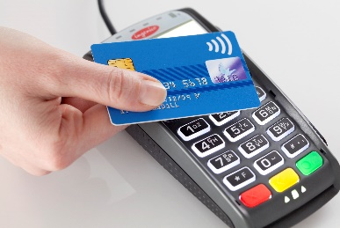**CeFS Pre-Task**

**Hannah wants to go contactless!**

Hannah, aged 18, often buys items that do not cost very much, such as cups of coffee, sandwiches, stamps and newspapers. She always needs to carry some loose change to pay for these items, which she finds inconvenient. She is also concerned that she might lose this money or have it stolen.

She would prefer to use a card for such transactions and has seen advertisements on television for contactless bank cards. In one of them, the ‘Feel Faster, Flow Faster’ advertisement by Barclaycard, the man seems to be getting increasingly younger as he uses his card. She thinks that a contactless bank card is a wonderful idea, but doesn’t know very much about them. She asks you to carry out some research on her behalf and to give her some advice and guidance on contactless bank cards.

She has recently passed her driving test and has been allowed to use her parents’ car on occasion. She thinks, however, that she might buy a second-hand car sometime in the future when she has enough money. She saved very diligently in order to pay for her driving lessons, although her parents and grandparents also contributed.

She has ‘got into the savings habit’ and has carried on paying regularly into a savings account. She only earns £240 net a week as a trainee hairdresser in the town centre, but she is very disciplined in terms of being able to regularly save £200 a month.

**Task**

Please answer the four questions on the following page and complete the research table. Please bring the completed work to your first finance lesson in September.

If you have any problems, please feel free to contact Mrs Heath - c.heath@hautlieu.sch.je

**Questions**

Read the command word instructions and answer the following:

1. Identify three advantages and three disadvantages of using contactless cards ***(5 marks)***
2. Discuss how external factors could affect people who use contactless cards ***(10 marks)***
3. Analyse how using contactless cards could help Hannah with her financial planning ***(10 marks)***

## Compare the use of a debit card with a credit card (5 marks)

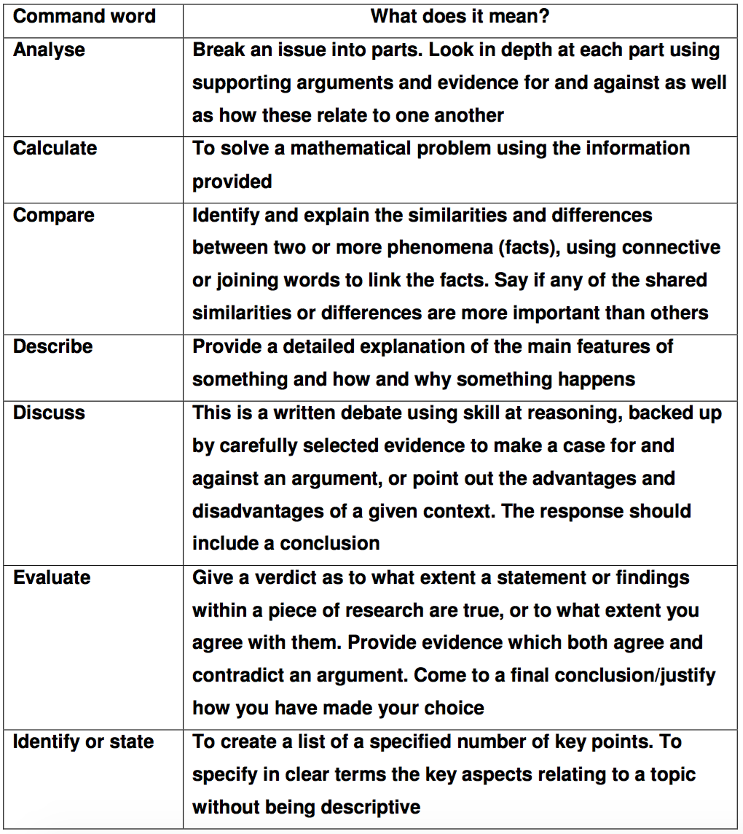







**Research Time!**

Hannah wants to switch savings accounts and needs an account that will give her the best return on her money. Research the following saving account factors for Barclays, Co-operative Bank and a 3rd financial provider of your choice. Fill out the table below.

|  |  |  |  |
| --- | --- | --- | --- |
|  | **Barclays** | **Co-operative Bank** | **(your choice)** |
| **Type of institution** |  |  |  |
| **Brief history of institution** |  |  |  |
| **Name/type of savings account** |  |  |  |
| **Interest rate** |  |  |  |
| **£ minimum deposit amount** |  |  |  |
| **Eligibility** |  |  |  |
| **Accessibility of money** |  |  |  |
| **Withdrawal of money** |  |  |  |
| **Guarantee Scheme (FSCS)** |  |  |  |
| **Online banking or App** |  |  |  |
| **Other information** |  |  |  |

**PARAGRAPH STRUCTURE - CeFS**

|  |  |
| --- | --- |
| **A REASON** | A **REASON** WITH **EVIDENCE** |
| **BECAUSE** | ANALYSE **WHY** THIS IS THE CASE IN **CONTEXT** |
| **CONSEQUENCE** | ANALYSE **HOW** THIS **IMPACTS** THE BUSINESS IN RELATION TO THE QUESTION |
| **DEPENDS ON** | WHAT FACTOR DOES YOUR POINT **DEPEND** ON E.G. Budget; economy; life cycle; social; demographics |

**EVALUATION:**

**Overall, I think / recommend this....  
Because of this... (use evidence if there is a case study)  
But it depends on....**

**CeFS – written answer structures**

5 mark questions: ½ side of A4

***List / State / Identify:***  *- literally list 6 separate points*

***Analyse / Describe / Compare 5 marks:***

All 5 mark questions follow the following structure: (READ the question – if it asks for benefits, do that)

* Point 1 – Benefit / feature / similarity – ABC
* Point 2 – Drawback / feature / difference – ABC
* Summary: Which of your points carries the most significance and why? Link to case study.

10 mark questions: 1 side of A4

***Analyse / Describe / Compare 10 marks:***

All 10 mark questions EXCEPT evaluate / discuss follow the following structure:

* Point 1 – Benefit / feature / similarity – ABC
* Point 2 – Benefit / feature / similarity – ABC
* Point 3 – Drawback / feature / difference – ABC
* Point 4 – Drawback / feature / difference – ABC (if time)
* Summary: Which of your points carries the most significance and why.

***Evaluate / Discuss / ‘To what extent’ 10 marks: (have to look at both sides)***

* Point 1 – Benefit / feature / similarity – ABC
* Point 2 – Benefit / feature / similarity – ABC
* Point 3 – Drawback / feature / difference – ABC
* Point 4 – Drawback / feature / difference – ABC (if time)
* ***CONCLUSION: OBB***

***Exemplar paragraph:***

*Analyse how an interest rate rise would be a risk Marcus & Miriam would need to consider in their decision.*

*As interest rates have been so low for the last decade it is likely that they will rise in the foreseeable future. This would increase Marcus and Miriam’s monthly repayments unless they had a fixed rate mortgage. Therefore, they may find repayments become less affordable which could lead to them having to cut back on other areas of expenditure. This shows that rising interest rates are a risk that need to be considered when taking out a mortgage.*