HAUTLIEU SCHOOL HISTORY DEPARTMENT A Level Induction task
History (Route E: Communism States in the twentieth century)
Capitalism or Communism, You decide!

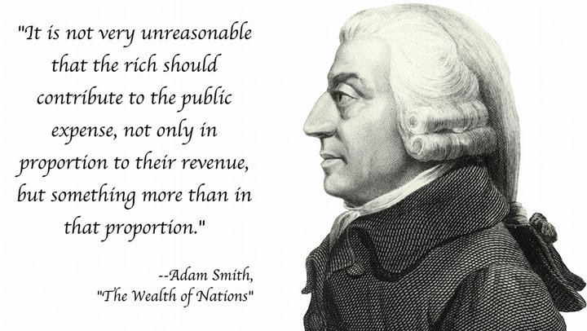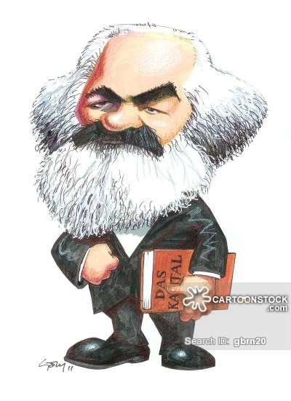
“The theory of communism may be summed up in one sentence. Abolish private property!”
Overview:
Both our exam modules in the first year of the A level course will be looking at two countries that attempted to set up Communist governments based on Marxist ideas. Russia (the USSR) experiment began in 1917 and ended in 1991! Ask your parents what they remember about the USSR. For China their experiment started in 1949 and still continues! A number of compromises have had to be made along the way to retain the one party state in modern day China. In practice it seems that Marx’s ideas have been diluted and modified. We’ll explore this in greater depth as part of our A level course.

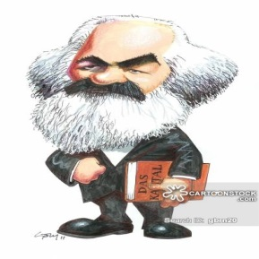
Induction Task History
Instructions: Produce a 1000 word written analytical response answering question 1 and 2 below.
- Your answer should show evidence of precise research and critical thinking.
- You must list at the end of your piece any websites and books you’ve used.
- Your response should be split into two parts to answer the two questions in bold below.
PART 1: (Produce 500 words use the following bullet points to help you put in the right content)
Question 1 - Who was Karl Marx and why did his ideas become an attractive alternative to capitalism? (Aim for 500 words, use the bullet points to guide you)
- Background & influences (Friederich Engels)
- Explain why he became critical of capitalism. Think about the industrial revolution and the problems and hardship it caused and gaps between the very rich and poor.
- What did he offer as an alternative? Discuss his idea of socialism and communism as a better alternative to capitalism. Are there any flaws/weaknesses to his argument?
- How did he see this becoming a reality? Which particular countries did he think would be suitable?
Question 2: Why did countries like Russia in 1917 and China in 1949 attempt to establish a new regime based on Marxist ideas? How successful were they in staying true to Marxist ideas in your opinion? (Aim for 500 words, use the bullet points to guide you)
- Show understanding of how the conditions in each country (war, lack of confidence in the existing governments) made Marxist ideas more attractive.
- Identify the key leaders and their parties who successfully took power. (Russia, Lenin & the Bolsheviks and China, Mao and the CHINESE Communist Party CCP).
- Were these countries ready to put into place a Marxist state? If not why? Draw upon examples from each country.
- In order to keep power did Lenin and Mao find themselves having to adapt Marxist ideas and even go back on or sacrifice some of their original aims?
Conclusion: Do you think it is fair to call these countries Marxist Communist states? If not why?
Deadline: Hand in first lesson September to your teacher.

Recommended research to start you off.
Try and find your own sources too from reputable websites and books from respected historians. A Level will require you to adopt an investigative approach.
(Please quote any direct reference, avoid cutting and pasting without saying where you got the quote from as this is plagiarism).
You should also bring in your research and store it in your history folder.
__________________________________________________________________________________
GCSE level material to get the foundations in place.
http://www.bbc.co.uk/history/historic_figures/marx_karl.shtml
http://www.bbc.co.uk/history/historic_figures/mao_zedong.shtml
http://www.historylearningsite.co.uk/modern-world-history-1918-to-1980/china-1900-to-1976/mao-zedong/
http://www.bbc.co.uk/history/historic_figures/lenin_vladimir.shtml
__________________________________________________________________________________
A Level standard reading material
http://www.sparknotes.com/philosophy/marx/context.html (Karl Marx)
http://spartacus-educational.com/RUSlenin.htm
http://spartacus-educational.com/COLDmao.htm
________________________________________________________________________________
Stretch material
http://www.chinafile.com/reporting-opinion/viewpoint/why-marx-still-matters-ideological-drivers-chinese-politics

