Name……………………...............

HAUTLIEU SCHOOL CHEMISTRY
Pre A Level and IB Diploma Task 2022

Expectations
- All sections of the task will be attempted – please check you have answered all questions (check all 11 pages)
- Answers should be presented in a clear and well-structured manner on lined paper with pages numbered and your name on all pages (we can staple when you hand it in)
- Answers should include an appropriate amount of relevant detail
- All parts of the task are to be handed in at the start of your first A Level or IB lesson in September
- Extra credit will be given for more detailed responses, but use bullet points rather than prose
- We have tried to use examples that will be used though the course so if there are names you are unsure about please look them up and try to remember them
- If you do not know something, please make every effort to find out the answer – doing this will help you to learn, this is not a test – use all the resources you can, it will help you to explore the available resources.

Content

- Revision of significant figures and standard form
- Naming compounds and writing formulae
- Writing equations
- Calculations from mass
- Bonding
- Qualitative analysis
- Groups in the periodic table
- States of matter and separation techniques
- Acids, bases and salts
- Rates of reaction

Requirements for the task and Chemistry lessons

- A scientific calculator (please buy one if you do not already own one)
- A copy of the Periodic Table (the one below should be sufficient)
- Access to Chemistry AS/IB textbooks (library) or internet articles – Chemguide is a good resource to start using early.

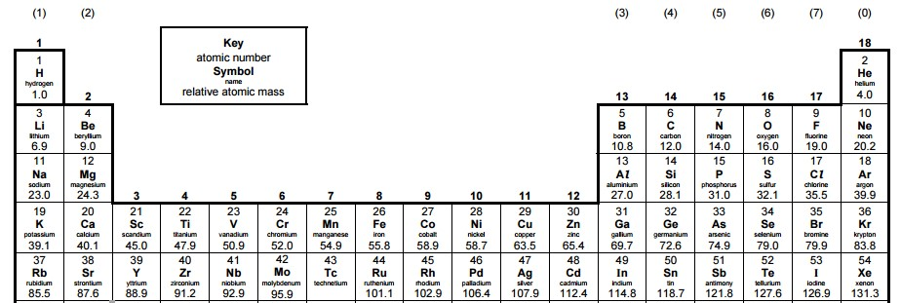

Significant Figures (sf) - General Rules – read carefully!
- Any digit that is not zero is significant
  - 86 has two sig figs
  - 274.8 has four sig figs
- A zero between non-zero digits are significant
  - 806 has three sig figs
  - 3001 has four sig figs
- Zeroes to the left of the first non zero number are not significant. They just show the position of the decimal place.
  - 002869 has four sig figs
  - 0.000767 has three sig figs
- If a number is greater than 1, then all the zeros to the left of the decimal point are significant as long as the decimal point is written. If the decimal point is not written, they are not significant. (The best way to avoid confusion is to use standard form.)
  - 250 has two sig figs.
  - In standard form this would be 2.5 x 10²
- For any numbers that contain a decimal, zeroes written to the right are significant.
  - 6.7810 has 5 sig figs
  - 0.00120 has 3 sig figs (the first three 0’s are not significant, the last one is)]
- For numbers written in standard form, all the digits written are significant.
    - 1.23 x 10⁻⁴ has three sig figs
    - 8.00 x 10⁹ has three sig figs

Additional Guidance for numbers in chemistry
Expected precision is 3 sf unless M_{r} (1dp) or pH (2dp) (best practice is to keep numbers in your calculator and round numbers at the end of your working).
You will need to be fluent in the use of standard form.
Questions
- Write the following numbers to the quoted number of significant figures.
a) 345789 | 4 sig figs | …………………
b) 297300 | 3 sig figs | …………………
c) 0.07896 | 3 sig figs | …………………

- Complete the following calculations and give the answers to 3 significant figures.
  - 6125 x 384 …………………
  - 25.00 x 0.01 …………………
  - 13.5 + 0.18 …………………

- Write the following numbers in non-standard form.
  - 1.5 x 10⁻³ ……………………
  - 0.046 x 10⁻² …………………
  - 3.575 x 10⁵ ……………………

- Write the following numbers in standard form.
a) 0.000167 | ……………………
b) 0.0524 | ……………………
c) 0.000000015 | ……………………

- Complete the following calculations and give the answers to 3 significant figures.
a) 6.125 x 10⁻³ x 3.5 | ……………………………
b) 4.0 x 10⁸ + 35000 | ……………………………
c) 0.00156 + 2.4 x 10³ | ……………………………

Naming Compounds – read carefully
When naming compounds there are two basic rules:
- When a metal and a non-metal element combine the compound name is something –ide (the metal element is always named first)
If sodium and chlorine combine you get sodium chloride
If magnesium and oxygen combine you get magnesium oxide
- When three or more different elements combine and one of them is oxygen the compound’s name ends in –ate
If copper, sulphur and oxygen combine you get copper sulphate
If sodium, nitrogen and oxygen combine you get sodium nitrate

Finding Formulae
To work out the formula when chemicals react, you need to look at the ions that form

 | Positive Ions |  |  | Negative Ions
1⁺ ions | 2⁺ ions | 3⁺ ions | 3⁻ ions | 2⁻ ions | 1⁻ ions
All group 1 metals: | All group 2 metals: | Aluminium – Al³⁺ | Phosphate – PO₄³⁻ | All group 6 elements: | All group 7 elements:
Lithium - Li⁺ | Magnesium -Mg²⁺ |  |  | Oxide – O²⁻ | Fluoride – F⁻
Sodium – Na⁺ | Calcium – Ca²⁺ |  |  | Sulphide – S²⁻ | Chloride – Cl⁻
Potassium – K⁺ |  |  |  |  | Bromide – Br⁻
 | Zinc – Zn²⁺ |  |  | Carbonate – CO₃²⁻ | Iodide – I⁻
Ammonium – NH₄⁺ | Most transition metals have a 2+ ion |  |  | Sulphate – SO₄²⁻
 |  |  |  |  | Hydroxide – OH⁻
 |  |  |  |  | Nitrate – NO₃⁻

For assistance with writing formulae check out the following video:
http://www.youtube.com/watch?v=URc75hoKGLY
Questions
Give the formulae of the following compounds
1) potassium iodide ………………… | 6) potassium sulphate …………………
2) sodium oxide ………………… | 7)aluminium hydroxide …………………
3) calcium sulphide ………………… | 8) potassium nitrate …………………
4) strontium chloride ………………… | 9) zinc carbonate …………………
5) iron (III) oxide ………………… | 10)ammoniumsulphate …………………

If you do not already know the formula of carbonate, sulphate, hydroxide, nitrate and ammonium ions, learn them – you WILL need them.

Equations
In Chemistry, one important skill is being able to write balanced chemical equations for reactions that have occurred.
These are some general equations you should be familiar with: Learn them if you are not!
Reaction | Examples
acid + alkali salt + water | HCl + NaOH NaCl + H₂O  H₂SO₄ + 2KOH K₂SO₄ + 2H₂O
Acid + base salt + water | H₂SO₄ + MgO MgSO₄ + H₂O
Acid + carbonate salt + carbon dioxide + water | 2HCl + MgCO₃ MgCl₂ + CO₂ + H₂O
Acid + metal salt + hydrogen | H₂SO₄ + Ca CaSO₄ + H₂
Substance + oxygen oxides | 2Mg + O₂ 2MgO  C₃H₈ + 5O₂ 3CO₂ + 4H₂O
Metal + water metal hydroxide + hydrogen | 2Na + 2H₂O 2NaOH + H₂
Metal carbonate metal oxide + carbon dioxide  (on heating) | CaCO₃ CaO + CO₂

Questions
Balance the following equations in the spaces underneath: not all the gaps need to be filled
- _____Mg + _____HNO₃ _____Mg(NO₃)₂ + _____H₂

- _____Ca + _____H₂O _____Ca(OH)₂ + _____H₂

- _____H₃PO₄ + _____CaO _____Ca₃(PO₄)₂ + _____H₂O

- _____HNO₃ + _____Na₂CO₃ _____NaNO₃ + _____CO₂ + _____H₂O

Give balanced equations for the following reactions (use the guidance on the previous page for help):
- Strontium carbonate strontium oxide + carbon dioxide
- Aluminium + chlorine aluminium chloride
- Ammonia + sulphuric acid ammonium sulfate
- Lithium + water lithium hydroxide + hydrogen
- Cyclohexane (C₆H₁₂) + oxygen carbon dioxide + water
- Hydrochloric acid + barium carbonate barium chloride + carbon dioxide + water

Relative formula mass
Remember that the relative atomic mass of an atom can be found by using the mass numbers of the periodic table. The relative formula mass of a compound is the sum of the relative atomic masses of the atoms involved. It is often given by the symbol M_{r}
Worked example 1:
What is the M_{r} of CaCO₃?
CaCO₃ has one calcium atom, one carbon atom and three oxygen atoms. The relative mass of calcium is 40, carbon is 12 and oxygen is 16. To calculate the total:
40 + 12 + (3 x 16) = 100
Worked example 2:
What is the Mr of Ca(OH)₂?
Ca(OH)₂ has one atom of calcium, two atoms of oxygen and two atoms of hydrogen (remember that everything in the brackets is multiplied by the little number. To calculate the total:
40 + (2 x 16) + (2 x 1) = 74
- For each of the compounds below calculate their M_{r}

  - CO
  - H₂O₂
  - SO₂
  - Na₂O
  - Al(OH)₃
  - Mg(NO₃)₂
  - CuSO₄
  - K₂SO₄
  - Al₂(SO₄)₃

  - A substance has an Mr of 180. A student knows that it has atoms of carbon, hydrogen and oxygen in it. What is its formula?
The mole

In everyday life, there are some words we can use which represent a number. For example:
A score = 20
A dozen = 12
A baker’s dozen = 13
These words exist because in different contexts those words are more useful than the numbers they represent. Someone selling eggs will refer to them “by the dozen” as eggs come in containers of six or twelve. So “dozen” is more useful than “twelve.”

In chemistry, we have a similar word called a “mole.” A “mole” is a word which represents a number
just like “dozen” represents “twelve.” A mole represents the number 6.02x10²³. This number is called The Avogadro Constant. This helps us to work in uncomplicated numbers.

- How many atoms are in:

- One mole of atoms
- Two moles of atoms
- Seven moles of atoms
- Half a mole of atoms
- A dozen moles of atoms

Worked example: Sodium has 11 electrons in each atom. How many electrons are in one mole of sodium atoms?
Answer: one mole of atoms is 6.02 x 10²³. If each atom has 11 electrons then there must be 11 x 6.02 x 10²³ electrons in total which = 6.62 x 10²⁴
- How many electrons are in:
- One mole of lithium atoms
- Two moles of carbon atoms
- One mole of carbon dioxide molecules
- Half a mole of methane molecules
- Challenge: A sample of iron metal is found to have 4.85 x 10²⁶ electrons in it. How many moles of iron atoms are present?

Moles and relative formula mass
The M_{r} of a substance represents the mass of one mole of that substance.
For example: water has the formula H₂O. Each molecule of water has two hydrogen atoms and one oxygen atom. Its M_{r} is 18. This means that 18 grams of water, contains one mole (6.02 x 10²³) of water molecules.
This leaves us with a formula relating moles, mass and M_{r}:
$$moles= \frac{mass}{Mr}$$

Worked example 3

How many moles are in 30g of CO₂?
The M_{r} of CO₂ is
12 + (16x2) = 44
Moles = 30/44 = 0.68
Worked example 4
How many moles are in 175g of Na₂CO₃?
M_{r} = (2 x 23) + 12 + (3 x 16) = 106
Moles = 175/106 = 1.65

- How many moles are in:

  - 198g CO₂
  - 144g CH₄
  - 102g NH₃
  - 1kg NaF
  - 1.2kg Ca(OH)₂

The equations can be rearranged to:
$mass=moles ×Mr$ and $Mr= \frac{mass}{moles}$
- What is the mass of:

- 5 moles of Cl₂
- 0.2 moles of Al₂O₃
- 0.01 moles of Ag
- 0.3 moles of Na₂CO₃

- An experiment was carried out to find the Mr of vitamin C (ascorbic acid). It was found that 1 g contains 0.00568 moles of Vitamin C molecules. Calculate the Mr of vitamin C.

Reacting mass calculations.
Worked example
Hydrogen and nitrogen react together to make ammonia (NH₃). Write a balanced symbol equation for this reaction and calculate how much nitrogen would be needed to react with 19.30 moles of hydrogen and how much ammonia would be produced.
First, we write the equation:
H₂ + N₂ NH₃
Then balance:
3H₂ + N₂ 2NH₃
Then we calculate our ratio:
÷3

H₂ | N₂ | NH₃
3 | 1 | 2
1  x 19.30 | 0.33 | 0.67
19.30 | 6.37 | 12.93
So 6.37 moles of nitrogen would be needed and would produce 12.93 moles of ammonia.

Guided practice:
Methane (CH₄) reacts with oxygen to make carbon dioxide and water.
- Write a balanced symbol equation for this reaction:
CH₄ + __O₂ CO₂ + __H₂O
- Fill in the top row of the table below with the numbers from your balanced equation
CH₄ | O₂ | CO₂ | H₂O
÷____

x _____
- If you started with two moles of CH₄, how much O₂ would you need? (the answer is 4, but you must use a calculation to prove this)
- If you started with 3.5 moles of CH₄, how much O₂ would you need?
- If you started with 3.5 moles of CH₄, how much CO₂ would you expect?
Ethane (C₂H₆) also reacts with oxygen to produce carbon dioxide and water:
2C₂H₆ + 7O₂ 4CO₂ + 6H₂O
- If 4 moles of ethane are used, how many moles of CO₂ are produced?
- If 5 moles of ethane are used, how many moles of H₂O are produced
- If 4 moles of ethane are used with 10 moles of O₂, how many moles of CO₂ are made?
- If 19 moles of oxygen are used, how much water is produced?
- How many moles of oxygen and ethane would you have to use to generate 42 moles of water?
Bonding, structures and properties

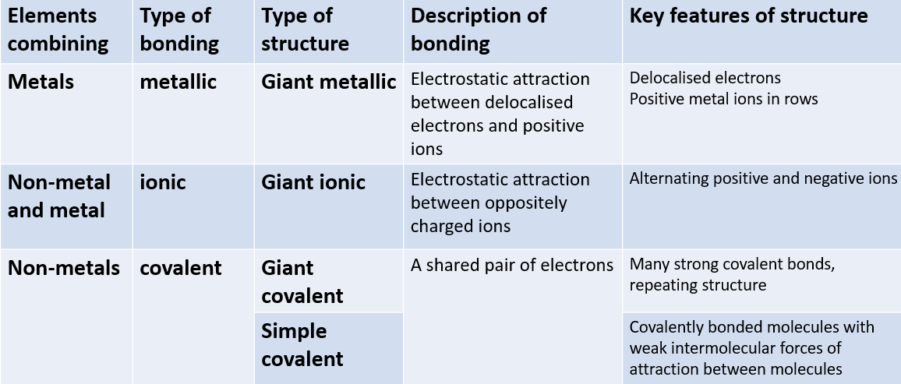

If a question asks about melting point or electrical conductivity you will have to refer to bonding and structure in your answer. Always start by checking the types of elements combining using the periodic table to see if they are metals or non-metals

Substance | Melting point | Conducts electricity when solid | Conducts electricity when liquid
A | high | no | no
B | high | no | Yes
C | High | Yes | Yes
D | low | no | no

- Which of the substances in the table could be…
- Sodium chloride (NaCl)
- Diamond (C_{(diamond)})
- Chlorine
- Iron
- Why does potassium have a lower melting point than sodium?
- Why would we expect MgO to have a higher melting point than NaCl?
- Why does CaCl₂ have a higher melting point than HCl?
Quantitative testing

There are many circumstances where we need to be able to quickly and definitely identify chemicals in the lab. We may want to know which chemical is which when we have forgotten to label them. We may need to confirm the product of a reaction to check that the reaction we intended has actually happened.

Identify the substances causing the changes described by giving the chemical name or formula (for some there may be more than one correct answer)
- A gas that turns limewater (Ca(OH)₂) cloudy
- A gas that relights a glowing splint
- A substance that turns universal indicator red
- Forms a white precipitate with (nitric acid) and silver nitrate
- Turns bromine water from yellow to colourless
- A gas that extinguishes a lit splint
- Forms a white precipitate with (hydrochloric acid) and barium chloride
- Turns anhydrous copper sulfate from white to blue
- A gas that makes a squeaky pop with a lit splint
- A negative ion that fizzes when acid is added
Periodic trends
It would be very hard to know every single property of every element, but it is not so hard to remember and use trends in properties from the arrangement of elements in the periodic table. Eg, down group 1 the elements increase in reactivity as the size of atoms increases and it becomes easier to lose the outermost electron as it is less attracted to the nucleus.

For each of the following pairs, pick the larger species
- Argon atom or potassium ion?
- Chloride ion or potassium atom?
- Magnesium atom or sodium atom?
- Sulfide ion or chloride ion?
- Magnesium ion or sodium ion?
- Oxide ion or chloride ion?
- Aluminium ion or aluminium atom
- Water molecule of hydrogen chloride molecule?
- Gold atom or water molecule?
- Fluorine molecule or chlorine molecule?
States of matter, separation of mixtures and purification techniques

Making a chemical is rarely as simple as just combining 2 ingredients and collecting the product. Usually what is made is a mixture of chemicals (unreacted reactants, solvents, possibly some unexpected oxides from oxygen in the air reacting) so it is important to know how to get the desired product from the reaction mixture.
The solubility rules in the table are useful to know
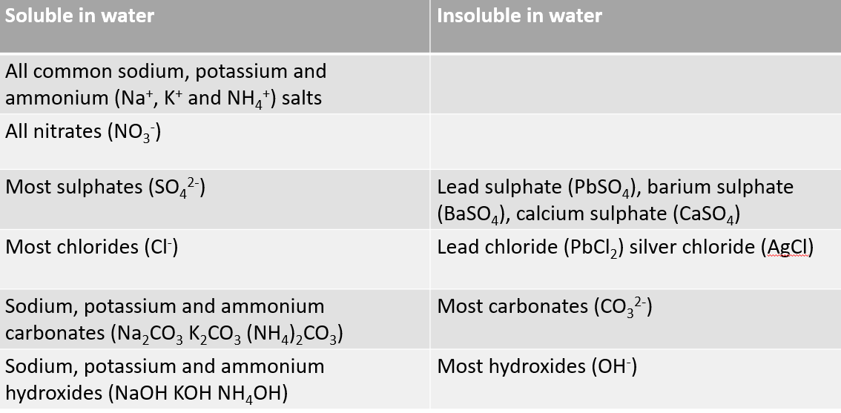

Filter, distil, dry, rinse with distilled water, leave to evaporate, drying agents eg, CaSO₄ react exact quantities are all techniques we can employ to obtain a better quality of product.

How would you separate and/or purify the following (to give the underlined substance)?
- A yellow precipitate of lead iodide from a solution of ions
- Sodium chloride from its solution
- Iron from a mixture of iron and sulfur
- Ethanol from a mixture of ethanol and water
- Water from sea water
Acids, bases and salts

A key area of chemistry that is useful in many aspects of our courses.

- Name and define a strong acid
- Name and define a strong base
- Name and define a weak acid
- Name and define a weak base
- Name and define a salt
- Give the most common equation for a neutralisation reaction
- Explain what phenolphthalein is
- How many NaOH would react exactly with 1H₂SO₄?
- Which has higher pH, NH₃ or CH₃COOH?
- Which has higher pH (at the same volume, same concentration), HCl or H₂SO₄?
Rates of reaction

Another key area of chemistry that appears in multiple contexts throughout the course

The following experiment was carried out: an excess of CaCO₃ chips were added to H₂SO₄ in a conical flask on top of a zeroed balance. The rate of reaction was monitored by recording the mass every 20 seconds until the reaction finished.

- How would the student know the reaction had finished?
- What happens in this reaction to cause mass to decrease?
- Why would this reaction proceed most quickly at the start?
- Give the units for the rate of this reaction
- Sketch the shape of the graph (mass (y axis) against time (x axis) for this reaction on labelled axes
- Give another way to monitor the rate of this reaction
- What would the difference be if the concentration of acid were doubled?
- What would the difference be if the CaCO₃ were switched for calcium oxide?
- The experiment was repeated at a higher temperature, explain why the rate increased?
- Aside from increasing temperature, give 2 ways in which the rate of reaction could be increased

THE END

