L3 DEC Summer task

Hi, it was great to see you at the induction sessions and hope they were useful. The summer task is an extension of the induction and to start to raise your expectations of what you can do from the foundation of GCSE to the student focused nature of L3 work.
1) you need to watch the video:
Abstract: Ólafur Eliasson: The Art of Design
On Netflix.
2) Then watch
How to Draw Buildings in 1-Point Perspective: Narrated
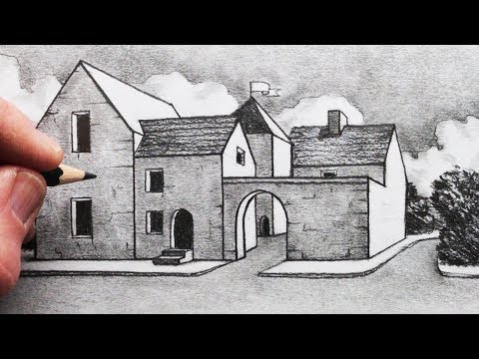

Or

How to Draw a House in 2-Point Perspective Step by Step

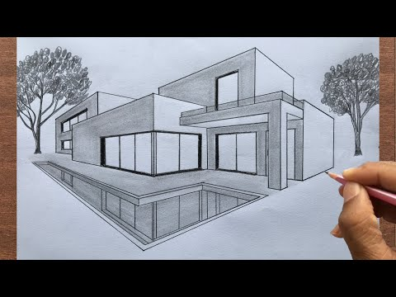
3) Copy out one of the above drawings
4) Design a modern or traditional house of your own design for a family of four for St Ouens or any other part of Jersey.
Complete a layout of your design and a perspective drawing of your design.
5) Look around St Helier and look above the shop fronts and take three photographs of different styles of architecture.
6) Draw one of the designs you photographed adding a good level of detail.

This work is due to be shown to your teacher the first lesson back in September and should take 4 to 6 hours.

Good luck, see you in September.

Mr Staveley/Mr Forestiero

