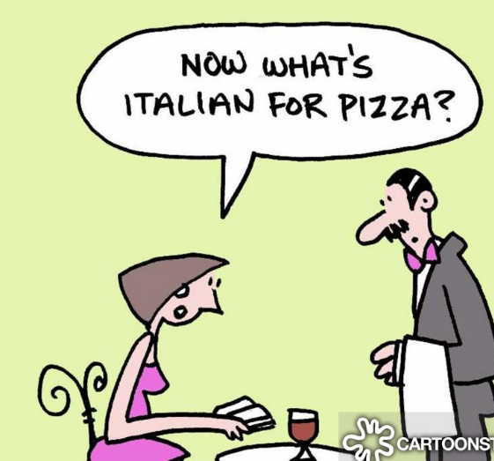
Italian IB

Bravissima/o ! hai scelto di studiare la piu bella lingua del mondo!
Well done ! you have chosen to study the most beautiful language in the world!
Understanding a little about the country and its culture will make it easier to learn the language.
I would like you to pick one area per week for research. There are 11 sections, so pick the areas that interest you most. If there is a different area that interests you that is not listed below, please add that to the list. The column on the right has suggestions- feel free to go with your own interests. I would like you to spend about 1 hour per week exploring each area.
write your findings in one of the following formats:
- Note book
- Powerpoint
- Word document
History | The Roman Empire  Renaissance  Unification of Italy  Fascist Italy in world war 2
Regions/Cities | Find out more about the food, history and people of a region or city of Italy- here are some suggestions:  Rome, Venice, Florence, Milan  Regions: Lombardia, Liguria
Art | Find out about Leonardo da Vinci or Michelangelo
architecture | Rome- Trevi fountain and Colosseum  Florence- Ponte Vecchio and Duomo  Venice- Rialto Bridge
literature | Find out about Dante’s La Divina Comedia and Machiavelli’s ‘The Prince/ il Principe’
cuisine | Explore the regional dishes in the south ( Sicily) and compare them to Liguria in the North
music | Italy is famous for opera.  Find out about Puccini- Madame Butterfly  Verdi- Rigoletto  Try to listen to some of the music
customs | Importance of family  La passeggiata  La bella figura
fashion | Versace  Armani  Fendi  Gucci  Prada
sport | Top teams in seria A  Famous Italian footballers
films | Watch and write a review on the following:  Bicycle thieves  Cinema Parediso  Il Postino  La Dolce Vita

Self-management skills
Firstly, the fact that you can choose which activities you carry out and put together a plan each week will allow you to develop your self-management skills and self-motivation skills. It will encourage you get yourself organised, thinking about how you can manage your time and tasks effectively, and understand what you can realistically achieve in a given amount of time. Perhaps you will under-plan or over-plan for one week, but this is something that you can reflect on and improve for the following week.
Thinking Skills
Carrying out these tasks each week will allow you to reflect not only on how efficiently you are planning, but also how interesting and valuable you find certain tasks and the way in which you complete them.

Communication Skills
These are not just related to speaking! Through immersing yourself in articles, books, magazines, blogs, and other online content, you will gain more of an understanding of the different aspects of Italian culture.

Social Skills
You may wish to build on these skills by doing some collaborative learning (digitally, of course!) and sharing some resources you have found, or even some learning activities you have created, with your peers. Explaining to a friend or a family member something interesting you have found out about Italian culture.

Research Skills
The more content you familiarise yourself with the abundance of information available online, the more you will be able to evaluate which types of sources are reliable and which ones aren’t so much. Familiarising yourself with reputable online sources, will give you a good head start for the research you will carry out as part of the IB course.

Good luck ( Buona fortuna)- I will be very excited to see your research in September!
Signora Kelleher

If you talk to a man in a language he understands, that goes to his head. If you talk to him in his language, that goes to his heart. Nelson Mandela

