**CeFS Summer Task 2023**

**Task**

Read the Case Study on Annie and Jim and mortgages. Answer the two essay style questions below.

1. **Analyse the considerations for Annie and Jim as first-time buyers, taking into account renting versus buying and the trends in prices paid for property.** *(10 marks)*
2. **Evaluate the suitability of the three mortgages in the product table in the additional information section of the question paper and recommend, with reasons, the most appropriate for Annie and Jim. Take into account Annie and Jim’s personal circumstances and the different features of the three mortgages.** *(15 marks)*

*Total = 25 marks*

**Top Tips**

* The questions are about the information and characters in the Case Study – use it throughout your answers!
* Look at the number of marks being awarded for each question.
* What do the command words mean?



* Make sure you cover **both** sides of the argument. Look at the example answer paragraph structure. For a 10 mark question you would expect a minimum of: 1 for and 1 against paragraph; whereas for a 15 mark question, it would be at least 2 for and 2 against paragraphs. BUT for this 15 mark question – you need to make comparisons between different factors, e.g. interest rates – so within this paragraph you would compare the 3 interest rates of the 3 mortgages. What other factors would you write about?
* Your work must be handwritten (unless you have exam access arrangements to use a laptop).
* **The work is due on your 1st finance lesson during the week commencing 4th September**
* If you have any problems, please feel free to contact Miss Carroll (Head of Business and Finance): [j.carroll@hautlieu.sch.je](mailto:j.carroll@hautlieu.sch.je)

**Case Study**

**Buying a property together**

Annie and Jim, both aged 27, were married a year ago. Since then they have been living with Annie’s parents while they save up for a deposit on a property of their own.

They both work full time. Annie is a manager at a local insurance company, and Jim, who also works locally, is a recruitment consultant with an agency. Annie’s gross salary is £32,000, and Jim earns £28,000. Jim can also earn commission of up to 50% of his annual salary, but this is dependent on him achieving his targets and so it is not guaranteed, especially at present as business is tough.

Annie and Jim have found it difficult to save enough for a deposit, as they were surprised how much mortgage lenders ask for. They have managed to save £9,000 between them, but this is much less than the amount required. They have decided to buy a two-bedroom cottage, because they would like to start a family as soon as possible. Where they live currently, this type of property costs around £200,000.

Annie’s parents plan to help them out by giving them £20,000. Annie and Jim are overjoyed.

Annie’s sister, Steffi, lives in a small cottage nearby and has spoken with Annie about how much they are likely to have to spend each month on bills. Steffi’s monthly household bills, excluding rent and food, are £575.

Annie and Jim do not have a car. They spend £250 a month on travel, which includes journeys to and from work as well as visiting friends. They each have a mobile phone, which costs a total of £60 a month. They are not sure how much buildings insurance will cost them, but they have assumed that £75 a month will be sufficient. In addition, they will have to cover the cost of their mortgage repayments and other bills, including food. Annie would also like them to be able to save some money each month so that they can have a holiday each year.

While taking their first step on the property ladder is exciting, they realise that this is a big decision and would like some information.

**The Research**

**To rent or buy?**

Moving away from their parents is one of the biggest decisions a person will make. Among other things, perhaps the primary decision is whether to buy a property, usually with a mortgage, or to rent, at least in the shorter term. While in the UK there is very much a culture of young people wanting to get on the property ladder, the reality is that many choose, or have no choice other than, to rent.

After a long period of gradual rises in house prices, especially in London and the South East, the increase slowed in the second half of 2019.

According to a report in *The Guardian*, the Halifax website stated that prices rose 1.1% year on year to £234,853, marking the smallest annual gain since April 2013.

Russell Galley, the managing director of Halifax, said the latest figures remained “in keeping with the predominantly flat trend we’ve seen in recent months”. He said “underlying market indicators, such as completed sales and mortgages approvals, were broadly stable. For buyers, important affordability measures including wage growth and interest rates still look favourable. In the three months to September, house prices increased by 0.4%, up slightly from 0.1% in the three months to August. However, Galley expected house buying activity and price growth to remain subdued while economic uncertainty, around Brexit and the global outlook, persists.” (Source: [www.theguardian.com](http://www.theguardian.com))

Many experts suggest that it is important to check the costs of renting against the costs of buying a property. There are many costs that are hidden when you buy your own property, such as maintenance and repair bills. Similarly, when renting, especially in a block of flats, there may be maintenance costs associated with the grounds and upgrading fixtures and fittings. With both options, there are still the normal day-to-day costs of running a household, such as lighting, heating and so on.

**Table 1: Costs initially incurred when buying or renting a property**



**Loan-to-value (LTV)**

“Competition in the mortgage market has been steadily heating up, with lenders battling for business by offering low interest rates on fixed-rate mortgages, sweetening deals with fee discounts or waivers. First-time buyers are particularly active in the market and their mortgages are often at the higher end of the LTV spectrum. Lenders traditionally demanded bigger compensation on these mortgages by charging higher interest rates.” (Source: [www.ft.com](http://www.ft.com))

“As a general rule, the higher the LTV, the higher the risk on the part of the lender, as more money is being lent out to someone with less capital to put up front in the first place as a deposit. This translates into higher interest rates. A loan with a lower LTV ratio is less of a risk for the lender, and for the borrower since less is being borrowed, and so will generally be a cheaper product.

If you can afford the deposit, a mortgage with a low LTV will work out well in the long run with lower interest and a lower overall capital value to pay off. If you’ve got a good enough credit score, as well as the means to maintain the payments, a mortgage with a high LTV will allow you to get onto the property ladder with very little put forward up front.

High LTV mortgages are often desirable for first-time buyers with little up front capital, but given the risk involved, many opt instead to go through housing schemes like help to buy, which offers a similar outcome without quite so much danger.” (Source: [www.moneyexpert.com](http://www.moneyexpert.com))

**Table 2: Loan-to-value ratios**



Source: providers websites

**The offset mortgage**

Leanne Macardle, editor for Moneyfacts.co.uk explains offset mortgages like this: “offset mortgages, simply put, let you link your mortgage to your savings. The savings balance is used to reduce the amount of interest charged on the mortgage.

The way this works is by having your savings 'offset' against the value of your mortgage, so you'll only pay interest on your mortgage balance minus your savings balance. Your savings don't repay any of your mortgage, they just sit alongside it and save you interest.

With your offset mortgage, you can choose to either lower monthly payments or shorten the length of your mortgage term. The former allows you to reduce your repayments, while the latter keeps your payments the same but gives you the chance to become mortgage-free earlier.” (Source: [www.moneyfacts.co.uk](http://www.moneyfacts.co.uk))

Experience has shown that offset mortgages work best for those who are higher-rate taxpayers. For some borrowers, the use of offset mortgages could reduce the mortgage term by up to two years.

**Affordability/maximum amount of loan**

Affordability is influenced by a number of factors, eg the property value, the deposit size, the mortgage term and the borrowers’ income. Income is used as a ‘multiplier’ by providers to calculate the amount they might lend. The maximum multiplier has in the past been five times the income (based on gross annual income). Where the mortgage is in joint names, the second salary can also be taken into account. In more recent times lenders have adopted an ‘affordability assessment’ when calculating how much can be lent on a mortgage, and this will particularly focus on an applicant’s disposable income.

**Interest rate**

A major consideration for borrowers is the cost of finance. There are wide variations in interest rates charged by providers, but the major influence is the Bank rate, which is set by the Monetary Policy Committee (MPC) of the Bank of England. Changes in the Bank rate are shown in Graph 1.

**Graph 1: Changes in UK Bank rate between 2007 and 2019**



**House Price Index Summary: July 2019**

In July 2019, HM Land Registry published its summary of housing data for the previous 12 months.

It reported that first-time buyers paid on average 0.5% more than the previous year for their house purchases, compared to a 1.4% increase for former owner-occupier purchases. House prices overall grew by 0.9% in the UK, with Wales showing the highest growth of the four nations. Flats and maisonettes prices fell by 2% over the previous year.

The couple have decided to compare some mortgage product examples. *SEE ADDITIONAL INFORMATION – MORTGAGE PRODUCT TABLE on the next page!*

**Additional Information – Mortgage Product Table**

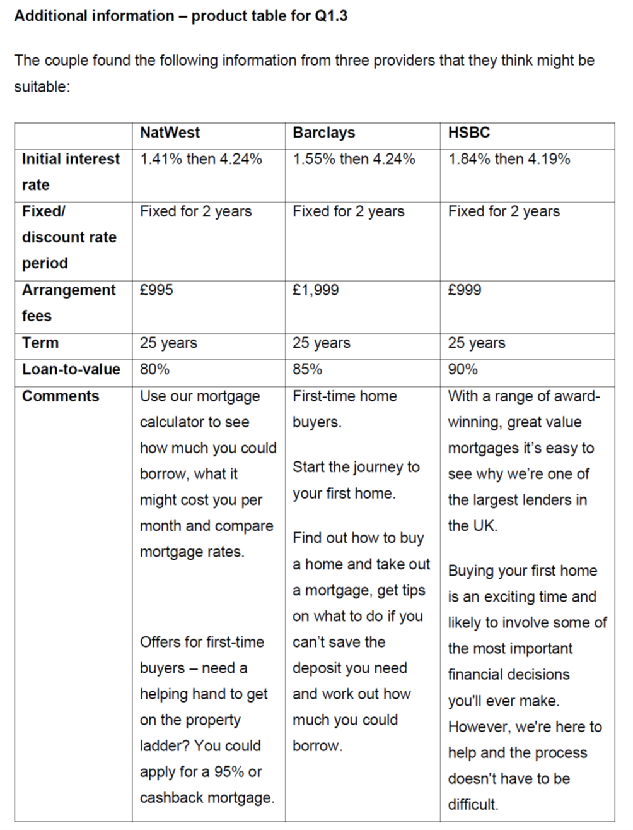

**PARAGRAPH STRUCTURE – CfS and DfS**

|  |  |
| --- | --- |
| **ABCD** | **WHAT YOU NEED TO WRITE** |
| **A FACTOR** | A **FACTOR** WITH **EVIDENCE** |
| **BECAUSE** | ANALYSE **WHY** THIS IS THE CASE IN **CONTEXT** |
| **CONSEQUENCE =**  **Walt** | ANALYSE **HOW** THIS **IMPACTS** THE FACTOR/PERSON IN RELATION TO THE QUESTION, IN **CONTEXT**. MAKE **LINKS**, INTER-RELATE …  (**W**hich means that …. **A**s a result …. **L**eading to …. **T**herefore…) |
| **DRAWBACKS**  ***(if relevant)*** | WHAT ARE THE **ISSUES** WITH YOUR ANSWER? HOW COULD THEY BE **RESOLVED**? |

**EVALUATION:**

**OVERALL,** I think / recommend .... what is your decision?  
**BECAUSE** ... reason why? With evidence (case study/context).  
**B**ut it **DEPENDS** on …?Choose most appropriate: e.g. Long/short-term; PESTLE; budget; demographics; circumstances of the character; economy ….etc.