A Level Design Technology Summer Task 2023
Hi,
It was great to meet you at the induction session and I look forward to seeing you in September. I hope you have a great summer break. The summer task builds on your experience of the induction session and they are part of raising the expectation of what you can do from the foundation of GCSE. As part of your A level course, you will be completing a design project. Work during Y12 will be a making project, graphic task skill builders and theory work, The project is focusing on enabling you to show the examiner you can be a young designer and solve problems for other people and come up with potentially commercially sound ideas (think dragons' den). An important part of this is communicating ideas, sketching: both line drawing and using colour. For your summer task you will be developing your 3D sketching style.
For your summer task you need to:
Complete the sketch exercises on the following pages. (1 to 1.5 hours)
Complete the product analysis task. (1 hour)
Complete the design exercise. (2 hours)
Mr Staveley/Miss Martin.
This might be useful:
https://youtu.be/CnKeVs-_9zs (Youtube>thinktank>Innovation)
http://www.tribu-design.com/en/
https://www.stem.org.uk/gcse-design-and-technology-resources
Google: pen and pencil product design sketching

Sketch exercises:
- Change these isomeric sketches into 3rd angle orthographic drawings. They only need to be sketched but must follow the correct layout with plan, front, and end views. Only three views needed. Do the same for the Barcelona chair.
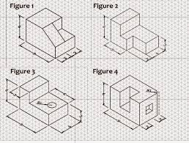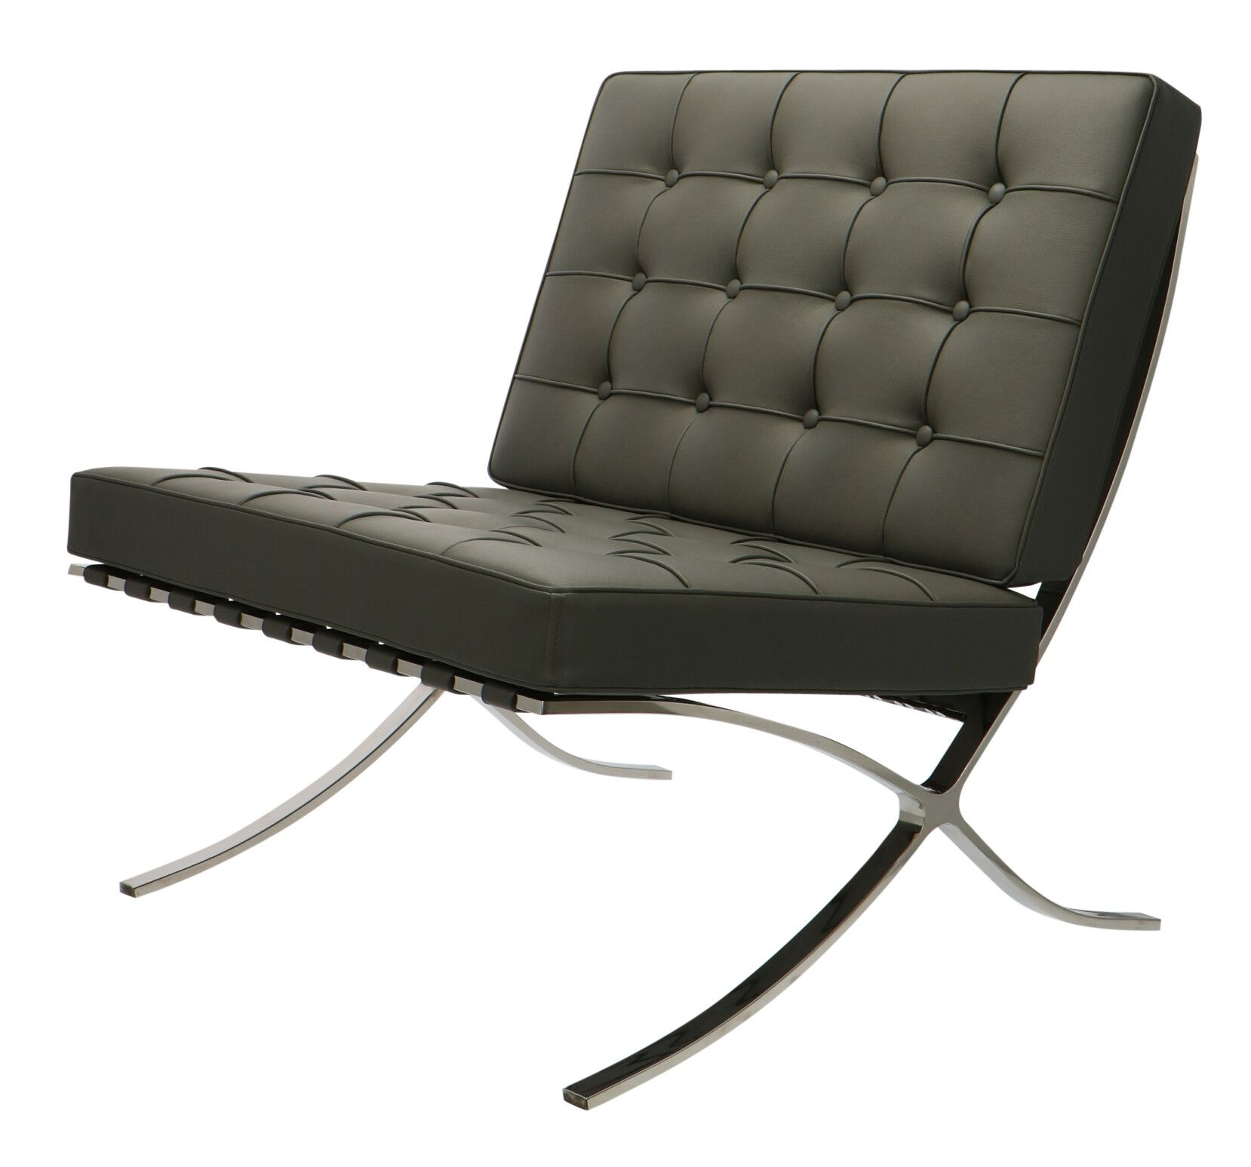
Example orthographic (with isometric in the top right corner):
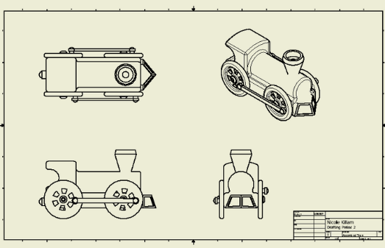

- Find a piece of furniture (coffee table, desk, bookcase) or an object (kettle, hairdryer, printer) and complete a 3D sketch of it and add notes to suggest what it is made from and identify the key elements such as top, legs, shelf or body, handle/grip etc.

- Complete a design sheet to show a design for a product that you have improved. It should have an image (photo or sketch) of the original product, 3 to 6 little simple line sketches to show potential ideas. A neat sketch with colour on at least half an A4 sheet showing the improved design with some notes. (Ideas: cup holder in my sofa, proper handle to carry my laptop, solar powered blue tooth speaker, battery manager device to tell you the charge state of all battery powered devices you own, Easy clean anti covid desk, goal posts that light up to confirm a goal has been scored for home/school use, hair straighteners that have automatic legs that fold in and out as you use it/put it down)

