Hautlieu - Physics Summer Task [35 marks]
Show all your workings
1. [1 mark]
What is the unit of power expressed in fundamental SI units?
A. ${kg m s}^{-3}$
B. ${kg m s}^{-1}$
C. ${kg m}^{2}{ s}^{-1}$
D. ${kg m}^{2}{ s}^{-3}$
2. [1 mark]
An object has a weight of 6.10 × 10² N. What is the change in gravitational potential energy of the object when it moves through 8.0 m vertically?
A. 5 kJ
B. 4.9 kJ
C. 4.88 kJ
D. 4.880 kJ
3. [1 mark]
How many significant figures are there in the number 0.0450?
A. 2
B. 3
C. 4
D. 5
4. [1 mark]
Two forces, F and G, act on a system.
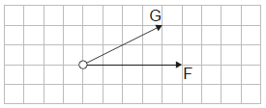
F is reversed in direction and G is halved.
Which vector correctly represents the new resultant force?
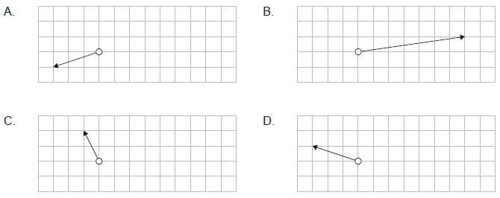
5. [1 mark]
Which is a vector quantity?
A. Acceleration
B. Energy
C. Pressure
D. Speed
6. [1 mark]
A river flows north. A boat crosses the river so that it only moves in the direction east of its starting point.
What is the direction in which the boat must be steered?
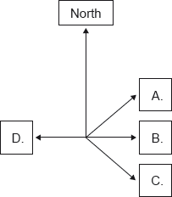
7. [1 mark]
The graph shows the variation of velocity of a body with time along a straight line.
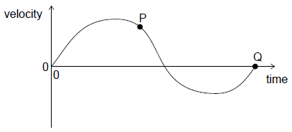
What is correct for this graph?
A. The maximum acceleration is at P.
B. The average acceleration of the body is given by the area enclosed by the graph and time axis.
C. The maximum displacement is at Q.
D. The total displacement of the body is given by the area enclosed by the graph and time axis.
8. [1 mark]
A runner starts from rest and accelerates at a constant rate throughout a race. Which graph shows the variation of speed v of the runner with distance travelled s?

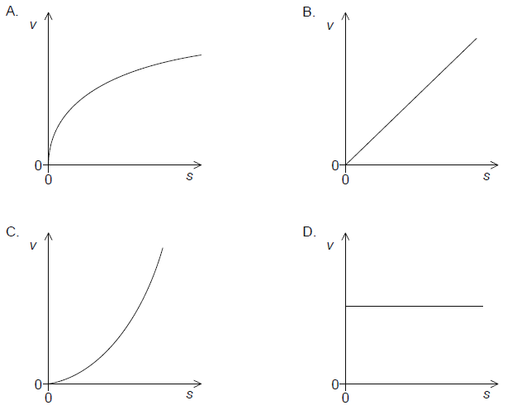
9. [1 mark]
The variation of the displacement of an object with time is shown on a graph. What does the area under the graph represent?
A. No physical quantity
B. Velocity
C. Acceleration
D. Impulse
10. [1 mark]
A rocket has just been launched vertically from Earth. The image shows the free-body diagram of the rocket. F₁ represents a larger force than F₂.
Which force pairs with F₁ and which force pairs with F₂, according to Newton’s third law?
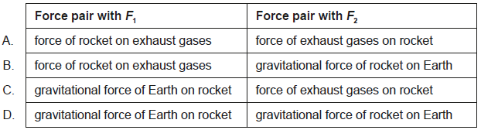
11. [1 mark]
Two forces act on an object in different directions. The magnitudes of the forces are 18 N and 27 N. The mass of the object is 9.0 kg. What is a possible value for the acceleration of the object?
A. 0 m s⁻²
B. 0.5 m s⁻²
C. 2.0 m s⁻²
D. 6.0 m s⁻²
12. [1 mark]
Two boxes in contact are pushed along a floor with a force F. The boxes move at a constant speed. Box X has a mass m and box Y has a mass 2m.
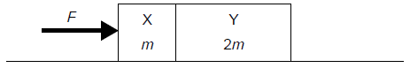
What is the resultant force acting on Y?
A. 0
B. $\frac{F}{2}$
C. F
D. 2F
13. [1 mark]
An object of mass 1.0 kg hangs at rest from a spring. The spring has a negligible mass and the spring constant k is 20 N m⁻¹
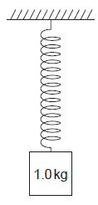
What is the elastic potential energy stored in the spring?
A. 1.0 J
B. 2.5 J
C. 5.0 J
D. 10 J
14. [1 mark]
A ball is thrown vertically upwards. Air resistance is negligible. What is the variation with time t of the kinetic energy E_{k} of the ball?
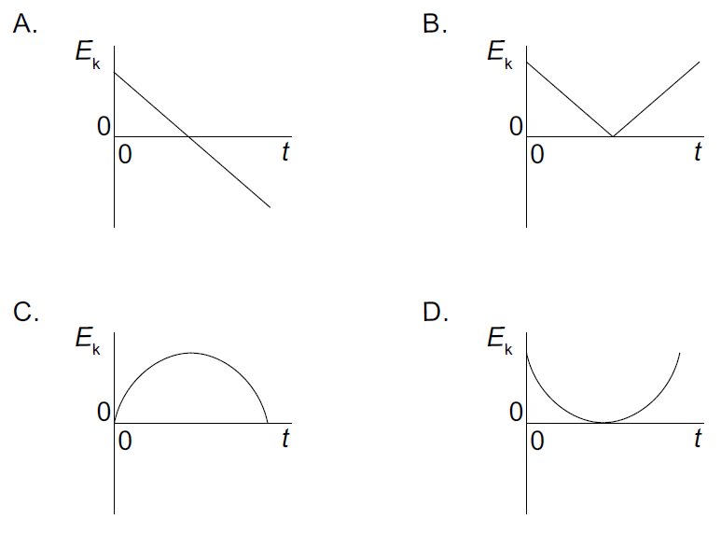
15. [1 mark]
The mass at the end of a pendulum is made to move in a horizontal circle of radius r at constant speed. The magnitude of the net force on the mass is F.
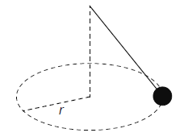
What is the direction of F and the work done by F during half a revolution?

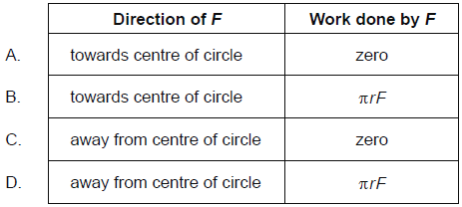
16. [1 mark]
The initial kinetic energy of a block moving on a horizontal floor is 48 J. A constant frictional force acts on the block bringing it to rest over a distance of 2 m. What is the frictional force on the block?
A. 24 N
B. 48 N
C. 96 N
D. 192 N
17. [1 mark]
The efficiency of an electric motor is 20 %. When lifting a body 500 J of energy are wasted. What is the useful work done by the motor?
A. 100 J
B. 125 J
C. 250 J
D. 400 J
18. [1 mark]
Two trolleys of equal mass travel in opposite directions as shown.
The trolleys collide head-on and stick together.
What is their velocity after the collision?
A. 1 m s⁻¹
B. 2 m s⁻¹
C. 5 m s⁻¹
D. 10 m s⁻¹
19. [1 mark]
Two identical blocks, each of mass m and speed v, travel towards each other on a frictionless surface.
The blocks undergo a head-on collision. What is definitely true immediately after the collision?
A. The momentum of each block is zero.
B. The total momentum is zero.
C. The momentum of each block is 2mv.
D. The total momentum is 2mv.
20. [1 mark]
A block of glass of mass 5 kg and temperature 30°C is brought into contact with a block of asphalt of mass 20 kg and temperature 75°C. The specific heat capacity of asphalt is twice that of glass. No energy is transferred to the surroundings. What is the final temperature of both blocks?
A. 35°C
B. 45°C
C. 60°C
D. 70°C
21. [1 mark]
A bicycle of mass $M$ comes to rest from speed $v$ using the back brake. The brake has a specific heat capacity of $c$ and a mass $m$. Half of the kinetic energy is absorbed by the brake.
What is the change in temperature of the brake?
A. $\frac{Mv^{2}}{4mc}$
B. $\frac{Mv^{2}}{2mc}$
C. $\frac{mv^{2}}{4Mc}$
D. $\frac{mv^{2}}{2Mc}$
22. [1 mark]
The graph shows the variation with distance $x$ of the displacement of the particles in a wave. The frequency of the wave is 600 Hz.
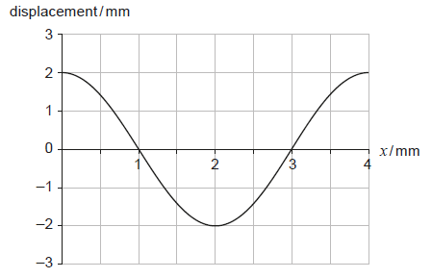
What is the speed of the wave?
A. 0.012 m s⁻¹
B. 0.024 m s⁻¹
C. 1.2 m s⁻¹
D. 2.4 m s⁻¹
23. [1 mark]
What changes occur to the frequency and wavelength of monochromatic light when it travels from glass to air?
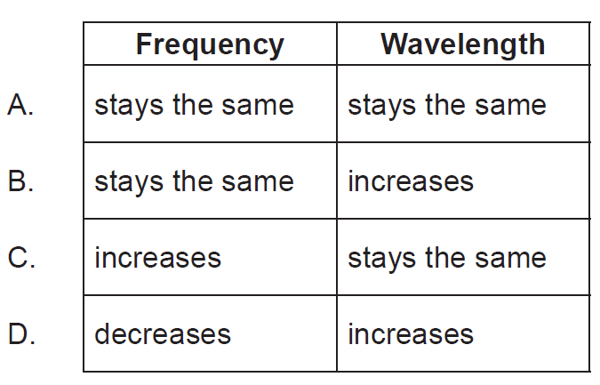
24. [1 mark]
The graph shows the variation of the displacement of a wave with distance along the wave.
The wave speed is 0.50 m s⁻¹.
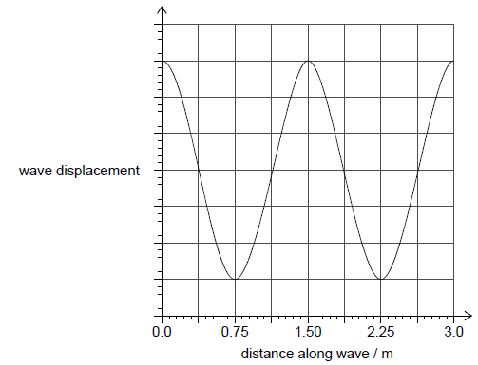
What is the period of the wave?
A. 0.33 s
B. 1.5 s
C. 3.0 s
D. 6.0 s
25. [1 mark]
In the circuits shown, the cells have the same emf and zero internal resistance. All resistors are identical.
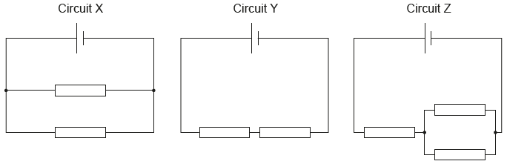
What is the order of increasing power dissipated in each circuit?
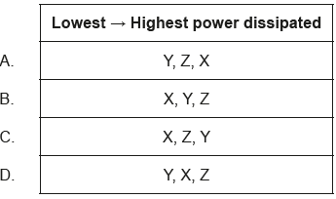
26. [1 mark]
An electric motor raises an object of weight $500 N$ through a vertical distance of $3.0 m$ in $1.5 s$. The current in the electric motor is $10 A$ at a potential difference of $200 V$. What is the efficiency of the electric motor?
A. $17 \%$
B. $38 \%$
C. $50 \%$
D. $75 \%$
27. [1 mark]
Four resistors of $4 Ω$ each are connected as shown.
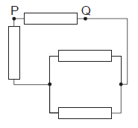
What is the effective resistance between P and Q?
A. $1.0 Ω$
B. $2.4 Ω$
C. $3.4 Ω$
D. $4.0 Ω$
28. [1 mark]
Three resistors are connected as shown. What is the value of the total resistance between X and Y?
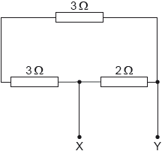
A. 1.5 Ω
B. 1.9 Ω
C. 6.0 Ω
D. 8.0 Ω
29. [1 mark]
A car on a road follows a horizontal circular path at a constant speed. What is the direction of the net force acting on the car and the direction of the instantaneous velocity of the car?
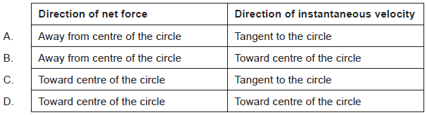
30. [1 mark]
The background count in a laboratory is 20 counts per second. The initial observed count rate of a pure sample of nitrogen-13 in this laboratory is 180 counts per second. The half-life of nitrogen-13 is 10 minutes. What is the expected count rate of the sample after 30 minutes?
A. 20 counts per second
B. 23 counts per second
C. 40 counts per second
D. 60 counts per second
31. [1 mark]
What statement about alpha particles, beta particles and gamma radiation is true?
A. Gamma radiation always travels faster than beta particles in a vacuum.
B. In air, beta particles produce more ions per unit length travelled than alpha particles.
C. Alpha particles are always emitted when beta particles are emitted.
D. Alpha particles are deflected in the same direction as beta particles in a magnetic field.
32. [1 mark]
Which property of a nuclide does not change as a result of beta decay?
A. Nucleon number
B. Neutron number
C. Proton number
D. Charge
33. [1 mark]
Which quantity has the same units as those for energy stored per unit volume?
A. Density
B. Force
C. Momentum
D. Pressure
34. [1 mark]
The graphs show the variation of the displacement y of a medium with distance $x$ and with time t for a travelling wave.
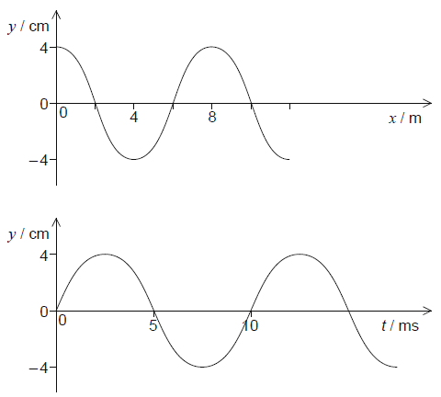
What is the speed of the wave?

A. 0.6 m s^{–1}
B. 0.8 m s^{–1}
C. 600 m s^{–1}
D. 800 m s^{–1}
35. [1 mark]
Which is a unit of force?
A. J m
B. J m^{–1}
C. J m s^{–1}
D. J m^{–1} s

