IB Visual Arts – Summer Task 2023

The IB Diploma Programme visual arts course encourages students to challenge their own creative and cultural expectations and boundaries. It is a thought-provoking course in which students develop analytical skills in problem-solving and divergent thinking, while working towards technical proficiency and confidence as art-makers. In addition to exploring and comparing visual arts from different perspectives and in different contexts, students are expected to engage in, experiment with and critically reflect upon a wide range of contemporary practices and media. The course is designed for students who want to go on to study visual arts in higher education as well as for those who are seeking lifelong enrichment through visual arts.

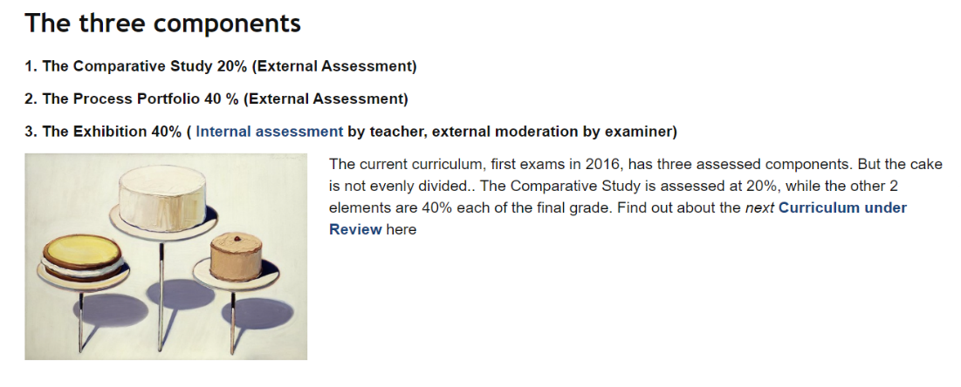

CLICK HERE for a clear overview of the course...

Function and Purpose is a way of understanding the artists’ intentions or another way of saying... what is it made for?
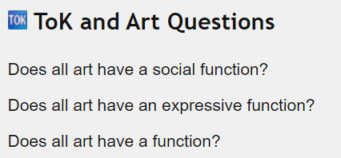
CLICK HERE FOR EXAMPLES...

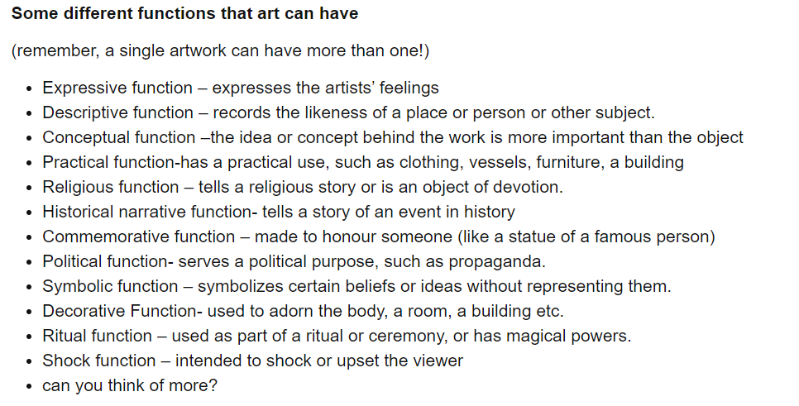

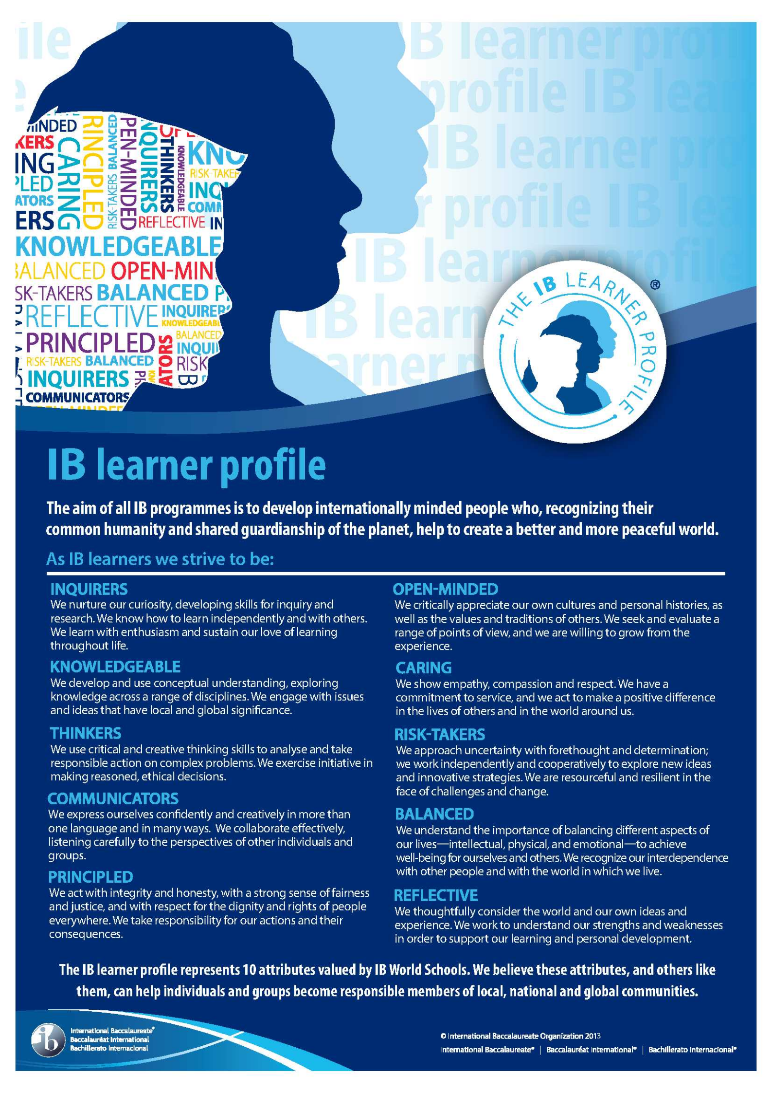
Summer Task Theme …
“ A Sense of Place”
- How do you see yourself in the world?
- Connections to Jersey / somewhere else…

Follow this 10 Step Process and create multiple sketchbook pages to ensure you tackle all Assessment Objectives thoroughly :
- Mood-board, definition and introduction to your idea
- Mind-map of ideas
- Artist References + Case Studies (must include image analysis)
- Photo-shoot
- Initial studies + detailed drawing
- Artwork Selection + sub selection, review and refine ideas
- Artwork manipulation / experimentation
- Presentation of final outcome(s)
- Compare and contrast your work to your artist reference
- Evaluation and Critique – reflection

