
School Nurse – Drop in Support Service


Dave Lund Nicky Phillips
Dave and Nicky, our School Nurses are offering one to one drop-in service in school, which is open to all students. Dave and Nicky can offer support and advice for all sorts of issues and concerns relating to well-being, physical and mental health. The sessions are confidential and will remain between the student and the school nurse. If a safeguarding concern is identified, information must be shared appropriately to keep the student safe from harm.
The next sessions in school will be:
Thursday 25th January 2024 10am to 12am – Student Support Office
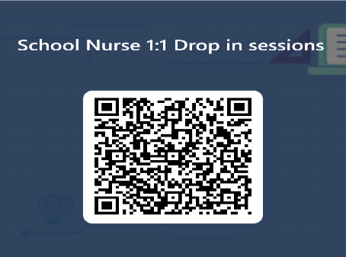
Thursday 8th February 2024 10am to 12am Student Support Office
Thursday 22nd February 2024 10am to 12am – Student Support Office
Thursday 7th March 2024 10am to 12am Student Support Office
Thursday 21st March 2024 10am to 12am – Student Support Office
Thursday 18th April 2024 10am to 12am – Student Support Office
Thursday 2nd May 2024 10am to 12am Student Support Office
Thursday 16th May 2024 10am to 12am Student Support Office
Please use the QR code if you would like to book a place or speak/email to Mrs Kedge for more detail l.kedge@hautlieu.sch.je
Appointments will be limited to first come first served basis.

