Best Christmas Decorated Mentor Classroom Competition

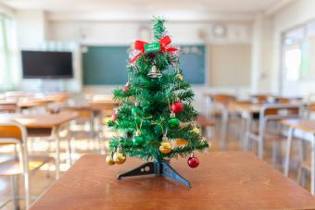

Please email [l.kedge@hautlieu.sch.je](mailto:l.kedge@hautlieu.sch.je) to enter your classroom, for a chance to win the public vote or the judge’s vote! Winners announced last week of term!

